Game evaluation report - Group 3

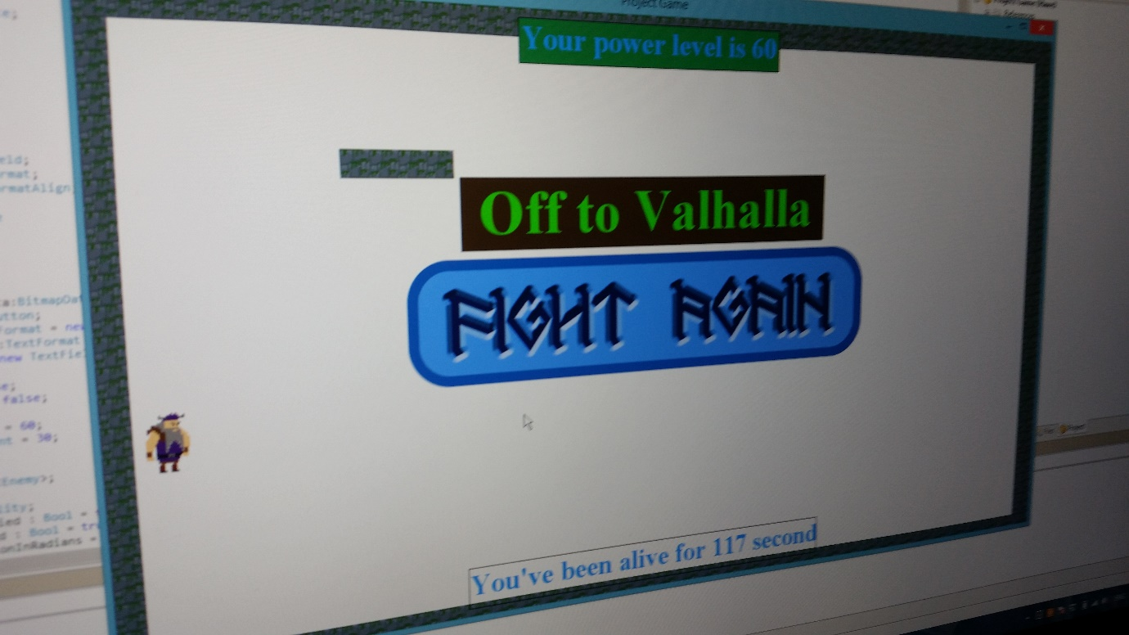

Group 3

17-01-2017

*Vasil Kichev*

*Floris Buskes*

*Alexandru Vasilachi*

*Kevin Boer*

*Rodney de Croon*

Table of contents

Introduction 3

Research strategy 4

Evaluation 4

Following is the full questionnaire we used: 6

Materials motivation 7

Questionnaire Results 8

Visual: 8

Audio: 8

Usability 8

Gameplay 8

Story/Theme 8

Recommendations 9

Photos of playtesting sessions 10

Introduction  
  
Our team decided to go with a pretty straight forward and simple game. This makes it easy to test and evaluate, but also to develop since, after all, we're learning Haxe from scratch. Even though we set out to make a simple game we quickly found out that the platformer we initially wanted to make would actually be very difficult and did not fit our usp very well. So we changed the design so it would both fit better and be more straight forward in programming. In the game the player controls a viking from a top-down perspective and must fight against infinite waves of enemies. The more enemies the player kills, the higher their score is. There are various abilities, which have a cool-down and are replaced by others when used. The amount of ability slots you have at any given time double as the health of the player.

Additionally, our endless wave of enemies gameplay is already very popular, so we can use previous research and know what to test for. The target audience is also well defined, so we can easily distinguish the people we're looking for, from people who are not relevant to our game.

“Does our game provide an enjoyable experience?” is our research question. We ask this question because it's very broad and covers a lot of bases. Because our game is not yet fully developed but still in progress and changing all the time, we need a rough idea of how everything is functioning. Later in the design process we can zoom in to more specific problems and mechanics and test their functionality but for now we do not want to limit ourselves.

We ask this question because our game went through multiple designs We want to make sure that the game is still enjoyable to play and the mechanics work together in the way we originally intended. We feel like when you change the mechanics of your game multiple times over the course of a project you run the risk of losing your intentional goal and the game can suffer for it. This questionnaire functions to detect and if necessary, prevent this from happening.

We plan our target audience to be people who enjoy videogames of ages between 16 and 40. Our game would appeal mostly to people who enjoy the beat-em-up genre that our game fits in. Our stakeholders would be our team and people generally interested in indie gaming.

## Research strategy

Of course the appeal of the game is crucial to our target audience, so we need to know what keeps them engaged and interested for long periods of time. This way we can decide what mechanics work well and if any need to change. A mechanic needing to change can be due to a variety of different things, a game can be extremely fun but when it is difficult to control that can take away from the player's experience.

One of these things we keep in mind when evaluating our game is the usability. When we let people playtest our game we keep a close eye to see if at any point they struggle to do what they want to. We of course also ask about this in the questionnaire but it is usually good to look for this yourself. Any mechanic that is unnecessarily unwieldy can be polished and tested again to see if the change made a difference.  
  
Test sessions will be set up with various students to evaluate our game. Our goal is to have around 20 people per playtest so we can get valuable data out of the test. This way we will hopefully be able to get a consensus of what players think. They will be given a questionnaire after the designated 20 minutes of play time. This is the maximum, so players are allowed to quit earlier. During this we will be watching, and if necessary helping them.

After the questionnaire we will also ask the playtesters if there is anything not covered by the questionnaire. This allows us to find out about things we did not think to ask, which helps us both improve the game and also any future questionnaire that we write. The questionnaire will provide essential feedback and statistics in addition to the qualitative data we will get in person.

## Evaluation

We divide the questionnaire into what we believe are the most important aspects of game design, we do this because our question is very general and we are trying to get information on all aspects of our game.

These aspects are: *gameplay*, *usability*, *story* and aesthetics which we divide up into *audio* and *visual* so we can get more in depth on these

We test our gameplay because that’s the core of our design. We decided to invest most of our design time towards gameplay, and the gameplay changed a lot over the course of the design process. Because of these reasons it can be hard to have a good view of how things are going sometimes. Some mechanics may have worked in the beginning but no longer fit, and some outside perspective on this can be very helpful in uncovering this.

We test the visuals of our game because we want to see if our art style fits the theme and gameplay. We test audio for the same reasons because although they may not impact gameplay directly, both are very important for player experience. This ties in with usability as things need to be conveyed clearly to the player so the game feels more natural.

We decided to test the theme of our game because we had some disagreements when we decided on it and were curious what players would think about it. There is also some overlap between theme/story and the aesthetics of the game, this is because the game's setting should be represented in a way that seems logical in order to keep the player in the flow of the game. If something suddenly looks very out of place this can have a negative impact on the players immersion.

Finally we look for any usability problems and room for improvement on this front. Bad usability is the only thing standing in the way of players experiencing our game the way we intend them to. Usability is in a separate category but most of the other categories also cover their main potential flaws with ease of use.

Using the questionnaire we can see if there are any problems in out game that many players don’t like, and where those problems are. By tracking where most players give negative responses we further investigate what the issue with that thing is. Besides that, we will also be observing and noting down any issues that come up naturally while playing. Because of the nature of a questionnaire and the types of questions we are asking on it, it is important that we also talk to the playtesters to see where exactly the problems lie. However we will not intervene when people are filling in the questionnaire as this might discourage them from being negative. We try to make sure people are brutally honest as negative views are much

more useful and interesting to us than positive ones.

## Following is the full questionnaire we used:

|  |  |  |
| --- | --- | --- |
|  | Visual |  |
| 1 | The games visual style remains consistent throughout the game | Likert scale |
| 2 | Did you notice any problems with animation and if so what? | Open |
| 3 | The art style fits the rest of the game | Likert scale |
| 4 | The visuals have enough detail | Likert scale |
| 5 | All important game elements are clearly visible | Likert scale |
|  |  |  |
|  | Audio |  |
| 6 | Audio is of high quality | Likert scale |
| 7 | The sound effects fit the theme of the game | Likert scale |
| 8 | You can distinctively hear all the important audio through the other sounds in the game | Likert scale |
| 9 | Audio feedback is instant | Likert scale |
| 10 | The music doesn't distract from the gameplay | Likert scale |
|  |  |  |
|  | Usability |  |
| 11 | The combination between movement and abilities is intuitive | Likert scale |
| 12 | The keys used are convenient and intuitive | Likert scale |
| 13 | The UI indicators are clear in what they are displaying | Likert scale |
| 14 | The mechanical differences between enemies is clear | Likert scale |
| 15 | The game is easy to learn | Likert scale |
|  |  |  |
|  | Gameplay |  |
| 16 | How would you describe the difficulty level of the combat? | Open |
| 17 | Hitboxes are accurate | Likert scale |
| 18 | New mechanics are introduced at an appropriate rate | Likert scale |
| 19 | There is a good amount of enemies on the screen at a time | Likert scale |
| 20 | Difficulty is not artificially inflated or unfair | Likert scale |
|  |  |  |
|  | Story/Theme |  |
| 21 | The world design fits the theme of the game | Likert scale |
| 22 | The story is clear | Likert scale |
| 23 | The story adds to the play experience | Likert scale |
| 24 | Does the theme fit the gameplay | Likert scale |
| 25 | There is a good amount of different characters | Likert scale |

## Materials motivation

As you can see most of these questions are likert scale, this is a deliberate choice so we can get large amounts of data in a relatively short time. We choose for quantitative data over qualitative because with this evaluation we are looking to get a broad idea where issues lie and where the game works well. We would then be able to go back and have more people play the game and ask questions based around the answers we got from this initial questionnaire. This second round of testing would be a more qualitative face to face interview so we can get very specific information on what to fix. This of course does not mean that we cannot draw conclusions and make changes to our game based on this questionnaire.

We also try to state questions in such a way that the problem becomes clear should there be one. So instead of asking 'How easy is the game to learn?' we ask 'The game is easy to learn'. This way people can say strongly disagree and we can assume the game is too difficult to learn where with the other option we are still clueless on what is wrong and what to change.

## Questionnaire Results

The playtesters have filled in our questionnaire and we as the designers should find results for our game.

### Visual:

From our results we found out that the visuals of our game is actually not that great because it lacks detail, our text is not consistent with the rest of our art and the testers were a bit undivided with our UI because the UI hides some of the terrain which can be irritating, we also concluded that we needed more animations because the only animated character Is the playable character which they liked.

### Audio:

Our testers said the audio in itself was of a high quality because you only hear one 8-bit music track,  
there was a downside of our music track because it did not sound that fit for a Viking game because the whole 8-bit tunes don’t sound like a Viking song, but what so ever they liked the 8-bit metal music even though it did not fit the theme.

Usability:

When we asked our testers about the usability of the game they mainly said they hated it because the movement and abilities are somewhat countering each other because you have to press the ability button near the walking buttons and not everyone was used to that, but however they said the game is easy to learn because the mechanics are easy to understand that you will feel quickly comfortable with.

The enemies are 16x16 pixels which means they are very small and some testers did not see some of them that clear enough which was the reason they died in the game.

Gameplay:

Some of the testers said that the game was to easy and some said it was way too hard but we also had a few of testers that said the game was fine enough for the difficulty they played on, a lot of people said that the hitboxes are not accurate because the corners have some issues when you don’t touch them you can still die.

The mechanics that we introduced to the people were simple and many people had almost to none issues with them, whenever they killed some enemies they respawn again everyone loved the numbers of enemies.

### Story/Theme

The testers said that we don’t have much world design, although the theme that we have for the game is clear and the testers said this was very clear because the character you play and the map you play on, they liked and disliked the amount of characters in the game because there are is not that much different enemies which for the other testers they said it was way better not to have too many different characters.

## Recommendations

One the most popular recommendations we got from out playtesters was to fix the hitboxes. They seemed a bit too big sometimes, and many people said they look broken or buggy. One of the possible solutions would be to make them smaller for projectiles. They will at least look better that way. We should try doing that and testing it again.

Another thing we need changed is the number of enemies. Many people complained there were too many of them to be able to deal with them. People that were able to deal with them, did that by evading them, instead of defeating, which is totally not the type of gameplay we were trying to implement. We are going to try to lower the number of enemies for now, until we implement all of the features we were planning for the game. After that we will address this topic again.

Lack of audio feedback has to be addressed as well. We need to make sounds for all the actions in the game, so that players have additional feedback, especially for failed actions. Otherwise it is a bit confusing for the player to know what exactly has happened or not.

Adding more animations should also help with that. Animations have to be clearer and more exaggerated, so that it is clear what characters are doing.

Besides that, the game requires some small adjustments, like better text formatting for UI, colors of different objects should fit together a bit better, and other things like that.

## Photos of playtesting sessions

